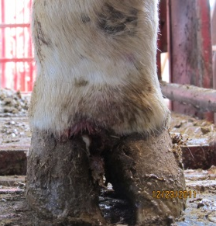
Description:
- Foot rot is caused by bacteria that enter the skin through a wound. Foot rot causes swelling above both claws. Typically there is loose dead tissue between the claws with a distinctive dead smell.

Criteria for treatment
- Any lame cow with swelling extending above both claws on one leg.
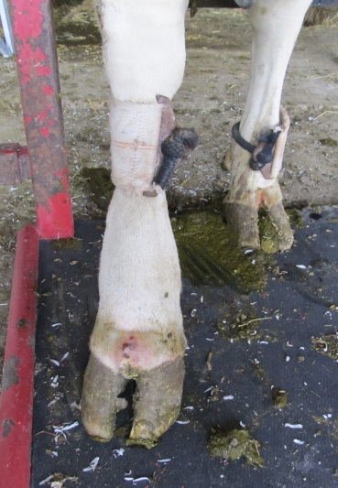
Treatment protocol
- Give cow 3mg/lb (1.5 ml/100 lb) of Excede
  - 22.5 ml for 1500 lb cow
  - Administer SQ at the base of the ear.
- Put cow in (pen #) if she is severely lame

Documenting treatment
- Record cow ID, date and treatment in cow records according to recording protocol.

Expected response to treatment
- Lameness should improve within 1-2 days after initial treatment.
  - Cow should be back to normal within 1 week.
- Reassess cow if cow does not improve
- Call (name veterinarian) further assistance if cow does not improve or swelling spreads

Milk/meat withdrawal times:
- 14 days meat
- 0 days for milk

