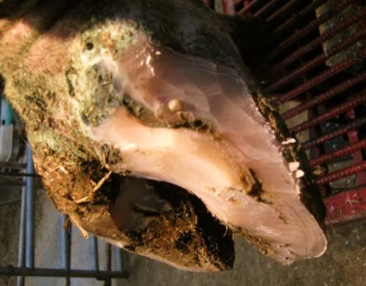
Description:
- White Line Lesions are the result of repeated trauma on hoof wall by the bone inside the foot (P3). This results in damage horned, separation and pockets of bacteria creating an abscess.
- Cows are typically very painful once the lesion reaches the abscess stage

Criteria for treatment
- Any lame cow presenting with separation of the white line area should be evaluated for a withdrawal response with hoof testers.
  - Any cow with a withdrawal response should be treated.
- Any cow with visible liquid from white line area should be treated

Treatment protocol
- Give cow a functional trim
  - Steps 1-3 of in functional trimming process
  - Resource: http://www.hoofhealth.ca/Section4/article4_01.html
- Follow separation of white line until all loose horn tissue around the lesion has been removed
  - Avoid touching the corium and causing bleeding.
  - Do not dig holes, but cup area to prevent trapping of manure.
- Lower affected heel up to the toe triangle.
  - Triangle on picture on right.
- Apply a block to the health claw
  - Ensure hoof is dry before applying block
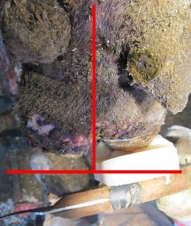
  - Position block appropriately at 90 degrees to leg bones
    - See applying a hoof block resource.
- Put cow in (pen #) if she is severely lame

Documenting treatment
- Record cow ID, date and treatment in cow records according to recording protocol.

Expected response to treatment
- Lameness should improve gradually after initial treatment.
  - Cow should be back to normal after about 2-6 weeks.
- All cows should be rechecked to remove block and evaluate healing after 4-6 weeks.
- If block falls off or if cow’s lameness worsens cow should be re-evaluated.
- Call (name veterinarian) further assistance if cow does not improve.
Milk/meat withdrawal times:
- None

